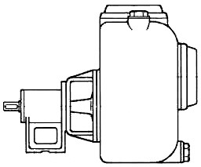

PRODUCT BULLETIN
MODEL LS PRONTO-PRIME
Bulletin 490LS
Edition 1a

The American-Marsh Model Pronto-Prime Self-Primer Pumps are designed for long, dependable life in many applications. The Model Pronto-Prime Self- Primer Pumps operate at 3500 RPM and 1750 RPM quietly and efficiently. These pumps are for use in aggressive applications where high quality and durability are requirements.
PRODUCT BULLETINMUNICIPALCOMMERCIALINDUSTRIAL
MODEL LS PRONTO PRIMEFiltration, Transfer, Backwash,Contractor De-wateringMining, Process, Backwash
SewageTransfer, Mill Scale

LS Models are available in close-coupled configurations and can be driven by electric, gasoline or diesel engines.

Material Specifications
PART | CONSTRUCTION
PART | STANDARD FITTED | BRONZE FITTED | 316 SS FITTED | ALL 316 SS
Casing | Cast Iron | Cast Iron | Cast Iron | 316 Stainless
Impeller | Cast Iron | Bronze | 316 Stainless | 316 Stainless
Shaft | Steel | Steel | Steel | 316 Stainless
Wear Plate | Rubber/Cast Iron | Rubber/Cast Iron | Rubber/Cast Iron | Rubber/Cast Iron
Bearing Housings | Cast Iron | Cast Iron | Cast Iron | Cast Iron
Gaskets | Nitrile Rubber | Nitrile Rubber | PTFE | PTFE
Mechanical Seal | Carbon/Cer/Buna | Carbon/Cer/Buna | Carbon/Cer/Buna | Carbon/Cer/Buna

MODEL LS PRONTO-PRIME SPECIFICATIONS

Casing: The casing is of high tensile cast iron or other specified material. It is of the self-primer, volute type with top discharge and large capacity priming chamber. Ports are provided for filling and draining of the casing. The power frame assembly can be removed from the rear of the casing (back pull-out) without disturbing suction or discharge piping. The casing has an impeller inspection cover that permits rapid access to the impeller to remove obstructions.

Impeller: The impeller is of the single suction, semi-open configuration designed for use in dirty and solid handling applications. It is made of high tensile cast iron, or other specified material, machined and dynamically balanced. The impeller is keyed to the shaft and secured by capscrew. Each impeller is designed to handle large diameter spherical solids.

Wear Plate: The casing is fitted with a renewable wear plate with oil and abrasion-resistant coating. The plate is constructed of heavy duty cast iron and held in place by capscrews. This wear plate can be replaced when worn to bring the pump back up to factory tolerances and efficiencies.

Shaft: The shaft is of carbon steel, ground and polished to a smooth surface. It is designed for extra stiffness to avoid all critical speeds in operation.
Shaft Sleeve: A stainless steel shaft sleeve is provided for protection of the shaft. This shaft sleeve can be easily removed and replaced as needed.

Power Frame: The power frame is constructed out of heavy duty cast iron and has provisions for grease lubrication to the inboard and outboard bearings.

Mechanical Seal: The mechanical seal is constructed of abrasion resistant materials for use in dirty applications. The mechanical seal is lubricated with grease and can run dry on high vacuum even when pumping highly abrasive liquids for approximately two minutes.

Bearings: The inboard ball bearing is of the single row type and the outboard bearing is of the double row type. They are of extra large capacity for both radial and thrust loads, and are pressed onto the shaft. The outboard bearing is designed for use with direct drive or can be used in applications where the use of pulleys are required. Each bearing is designed for grease lubrication and is supplied with a zerk fitting.

Bulletin 490LS
Edition 1a

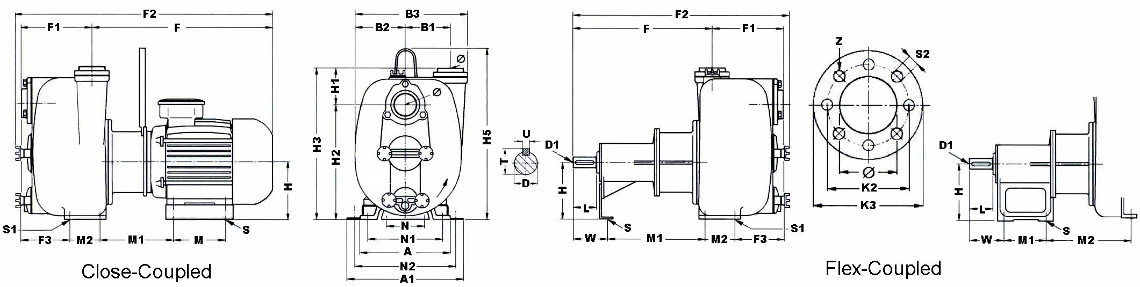

Approximate General Dimensions
- Your Local Authorized Distributor -

Pumps...and Pumps Only...Since 1873
(Do not use for construction purposes)
Close-Coupled Models Flex-Coupled Models
 | 1.5 LS | 2 LS | 3 LS | 4 LS
∅ | 1-½ | 2 | 3 | 4
A | - | - | - | -
A1 | 6.875 | 6.125 | 6.875 | 11.000
B1 | 1.250 | 1.000 | 1.375 | 1.188
B2 | 4.750 | 4.000 | 4.500 | 5.625
B3 | 9.500 | 8.000 | 9.000 | 11.125
F | 16.125 | 14.375 | 16.250 | 18.500
F1 | 3.625 | 3.500 | 4.500 | 6.000
F2 | 19.750 | 17.875 | 20.875 | 24.500
F3 | - | - | - | -
H | 4.375 | 3.125 | 4.375 | 5.375
H1 | 3.000 | 4.188 | 5.750 | 7.000
H2 | 7.625 | 5.875 | 5.875 | 7.000
H3 | 10.625 | 10.000 | 11.625 | 14000
H5 | - | - | - | -
K2 | - | - | - | -
K3 | - | - | - | -
M | 6.438 | 3.875 | 7.500 | 5.500
M1 | - | - | - | -
M2 | - | - | - | -
N | 4.000 | 3.875 | 3.875 | 4.000
N2 | 5.875 | 4.875 | 5.312 | 9.438
S | 0.250 | 0.250 | 0.250 | 0.250
S1 | - | - | - | -
S2 | - | - | - | -
Z | - | - | - | -
LBS | 73 | 49 | 71 | 130
SOLIDS | 0.312 | 0.625 | 1.000 | 1.500
HP | 5 | 3 | 5 | 10

 | 1.5 LS | 2 LS | 3 LS | 4 LS
∅ | 1-½ | 2 | 3 | 4
A | - | - | - | -
B1 | 1.250 | 1.000 | 1.375 | 1.188
B2 | 4.750 | 4.000 | 4.500 | 5.625
B3 | 9.500 | 8.000 | 9.000 | 11.125
D (metric) | 19mm | 19mm | 19mm | 19mm
D1 (metric) | M8 | M8 | M8 | M8
F | 16.125 | 14.375 | 16.250 | 18.500
F1 | 3.625 | 3.500 | 4.500 | 6.000
F2 | 15.375 | 12.500 | 20.875 | 18.375
F3 | - | - | - | -
H | 4.375 | 3.875 | 3.875 | 3.875
H1 | 3.000 | 4.188 | 5.750 | 7.000
H2 | 7.625 | 5.875 | 5.875 | 7.000
H3 | 10.625 | 10.000 | 11.625 | 14.000
K2 | - | - | - | -
K3 | - | - | - | -
L | 1.625 | 1.625 | 1.625 | 1.625
M1 | 2.000 | 3.500 | 3.500 | 2.000
M2 | - | - | - | -
N | 4.000 | 3.875 | 3.875 | 4.000
N1 | - | - | - | -
S | 0.250 | 0.250 | 0.250 | 0.250
S1 | - | - | - | -
S2 | - | - | - | -
T | 0.812 | 0.812 | 0.812 | 0.812
U (metric) | 6mm | 6mm | 6mm | 6mm
W | 3.000 | 2.375 | 2.375 | 3.000
Z | - | - | - | -
LBS | 35 | 31 | 40 | 75
SOLIDS | 0.312 | 0.625 | 1.000 | 1.500




All dimensions are in inches (except those noted).
Sales & Marketing: 185 Progress Road • Collierville, Tennessee • 38017
Manufacturing: 185 Progress Road • Collierville, Tennessee • 38017
Phone: (800) 888-7167
Fax: (901) 860-2323

